import cv2

import numpy as np

import matplotlib.pyplot as plt

name_gray = np.array([

[255, 0, 255, 255, 255, 255, 255, 0, 255, 0, 0, 0, 0, 255, 0, 0, 0, 0, 255],

[255, 0, 0, 255, 255, 255, 0, 0, 255, 0, 255, 255, 255, 255, 0, 255, 255, 255, 255],

[255, 0, 255, 0, 255, 0, 255, 0, 255, 0, 0, 0, 0, 255, 0, 0, 0, 0, 255],

[255, 0, 255, 255, 0, 255, 255, 0, 255, 0, 255, 255, 0, 255, 0, 255, 255, 0, 255],

[255, 0, 255, 255, 255, 255, 255, 0, 255, 0, 0, 0, 0, 255, 0, 0, 0, 0, 255]

])

plt.imshow(name_gray,cmap='gray')

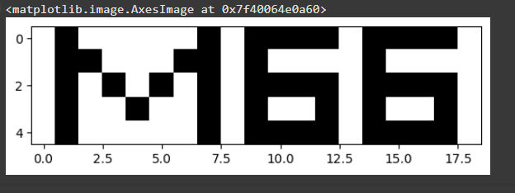

import cv2

import numpy as np

import matplotlib.pyplot as plt

from google.colab.patches import cv2_imshow

from google.colab import drive

drive.mount('/content/drive')

def transform_5(img_link):

img = cv2.imread(img_link)

r, c = img.shape[0], img.shape[1]

img_crop = img[:r//2, :c//2] # croping th image with half from row and half from column

img_flip = cv2.flip(img, 1) # horizontal flip

img_resize = cv2.resize(img, (int(c*0.4), int(r*0.3))) # making the image 70% smaller using resize

trans_arr = np.float32([[1, 0, 100], [0, 1, 100]])

img_translated = cv2.warpAffine(img, trans_arr, (c, r)) # translating the image with 100 pixel from x and y axis both

shear_arr = np.float32([[1, 0.3, 0],[0.3, 1, 0]])

img_sheared = cv2.warpAffine(img, shear_arr, (c + int(0.3 * r), r + int(0.3 * c))) # shearing the image with 30% from x and y axis both

_, (ax1,ax2,ax3,ax4,ax5,ax6) = plt.subplots(1,6,figsize=(20,8))

ax1.set_title('BGR')

img = img.astype('uint8')

ax1.imshow(cv2.cvtColor(img, cv2.COLOR_BGR2RGB))

ax2.set_title('Crop')

img_crop = img_crop.astype('uint8')

ax2.imshow(cv2.cvtColor(img_crop, cv2.COLOR_BGR2RGB))

ax3.set_title('Flip (Horizontal)')

img_flip = img_flip.astype('uint8')

ax3.imshow(cv2.cvtColor(img_flip, cv2.COLOR_BGR2RGB))

ax4.set_title('Resize')

img_resize = img_resize.astype('uint8')

ax4.imshow(cv2.cvtColor(img_resize, cv2.COLOR_BGR2RGB))

ax5.set_title('Translation')

img_translated = img_translated.astype('uint8')

ax5.imshow(cv2.cvtColor(img_translated, cv2.COLOR_BGR2RGB))

ax6.set_title('Shear')

img_sheared = img_sheared.astype('uint8')

ax6.imshow(cv2.cvtColor(img_sheared, cv2.COLOR_BGR2RGB))

def random_noise(img_link):

img = cv2.imread(img_link)

noisy_img = np.copy(img)

size = img.size

coordinates = []

n_salt = np.ceil(0.5 * size * 0.5).astype(int) # Salt noise (white pixels)

for i in img.shape:

coordinate = np.random.randint(0, i - 1, n_salt)

coordinates.append(coordinate)

noisy_img[coordinates[0], coordinates[1]] = 255

n_pepper = np.ceil(0.5 * size * 0.5).astype(int) # Pepper noise (black pixels)

for i in img.shape:

coord = np.random.randint(0, i - 1, n_pepper)

coordinates.append(coordinate)

noisy_img[coordinates[0], coordinates[1]] = 0

noise = np.concatenate(coordinates).flatten() # flattern the x, y coordinates or 2d matrix to 1d

_, (ax1,ax2,ax3) = plt.subplots(1,3,figsize=(30,8))

ax1.set_title('BGR')

img = img.astype('uint8')

ax1.imshow(cv2.cvtColor(img, cv2.COLOR_BGR2RGB))

ax2.set_title('Noisy Image')

noisy_img = noisy_img.astype('uint8')

ax2.imshow(cv2.cvtColor(noisy_img, cv2.COLOR_BGR2RGB))

ax3.hist(noise, bins=50, density=True, alpha=0.6, color='g')

ax3.set_title('Generated Random Noise')

ax3.set_xlabel('Value')

ax3.set_ylabel('Frequency')

plt.show()

transform_5('/content/img1.jpg')

random_noise('/content/img1.jpg')

transform_5('/content/img2.jpg')

random_noise('/content/img2.jpg')

transform_5('/content/img3.jpg')

random_noise('/content/img3.jpg')

transform_5('/content/img4.jpg')

random_noise('/content/img4.jpg')

transform_5('/content/img5.jpg')

random_noise('/content/img5.jpg')

transform_5('/content/img6.jpg')

random_noise('/content/img6.jpg')

transform_5('/content/img7.jpg')

random_noise('/content/img7.jpg')

transform_5('/content/img8.jpg')

random_noise('/content/img8.jpg')

transform_5('/content/img9.jpg')

random_noise('/content/img9.jpg')

transform_5('/content/img10.jpg')

random_noise('/content/img10.jpg')

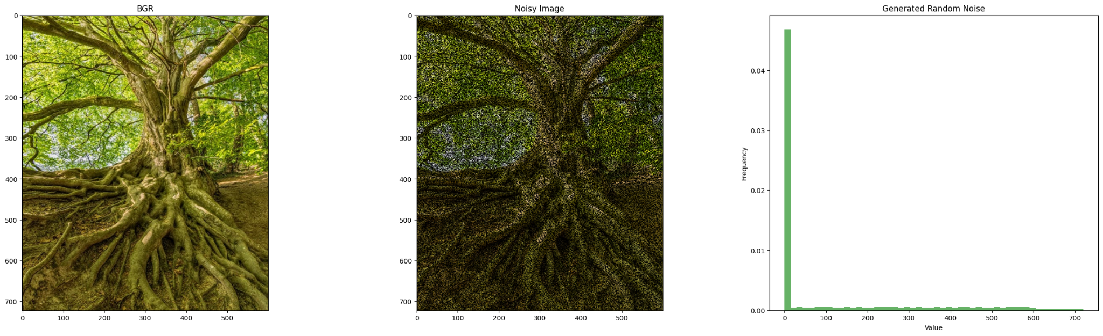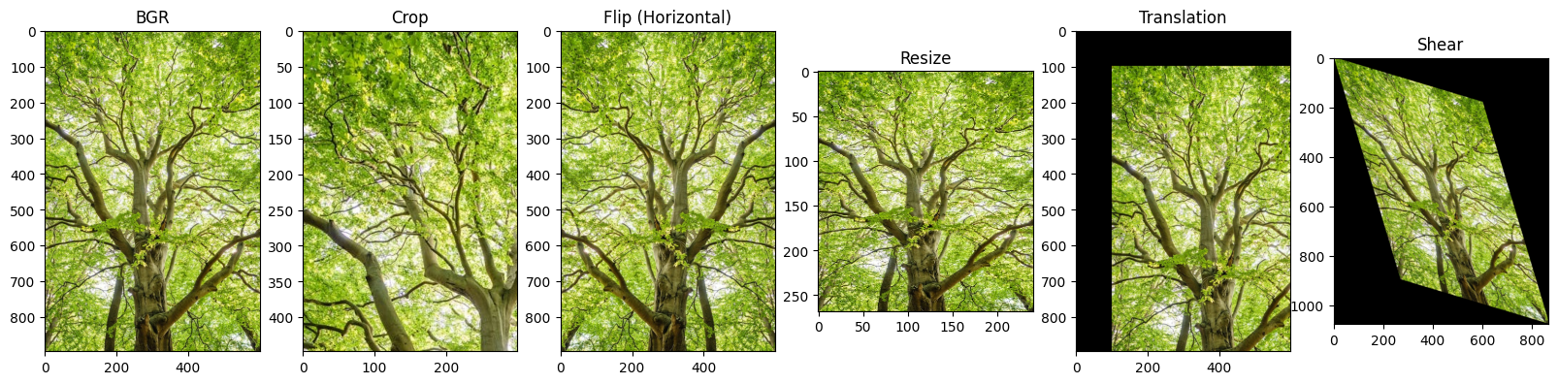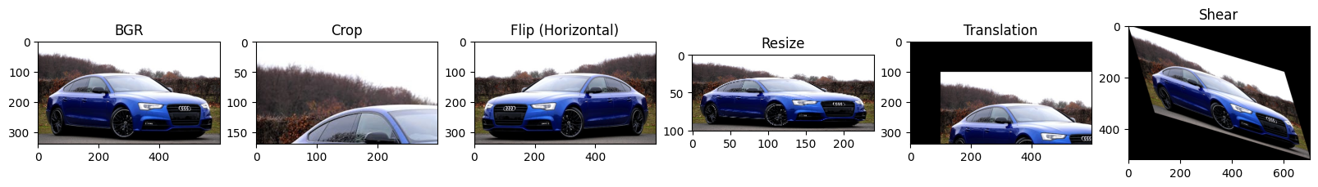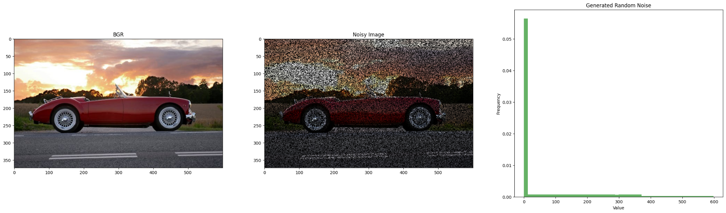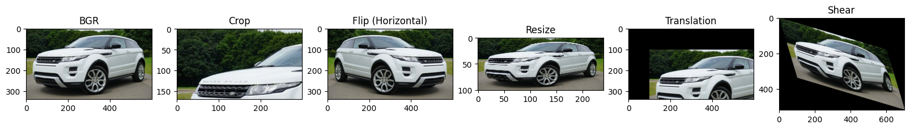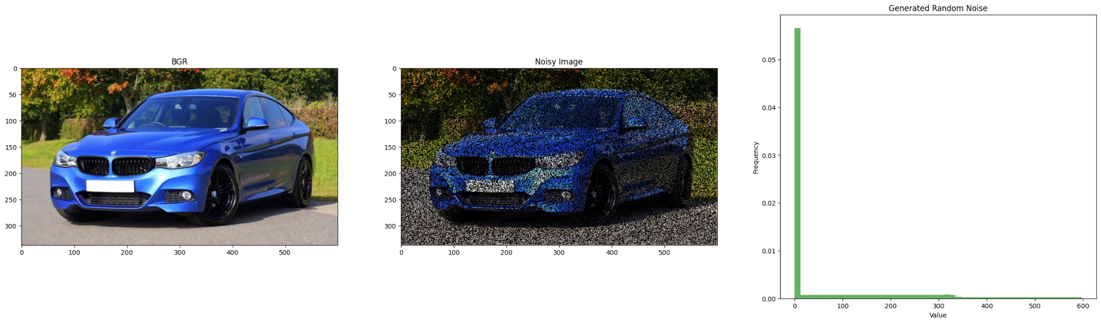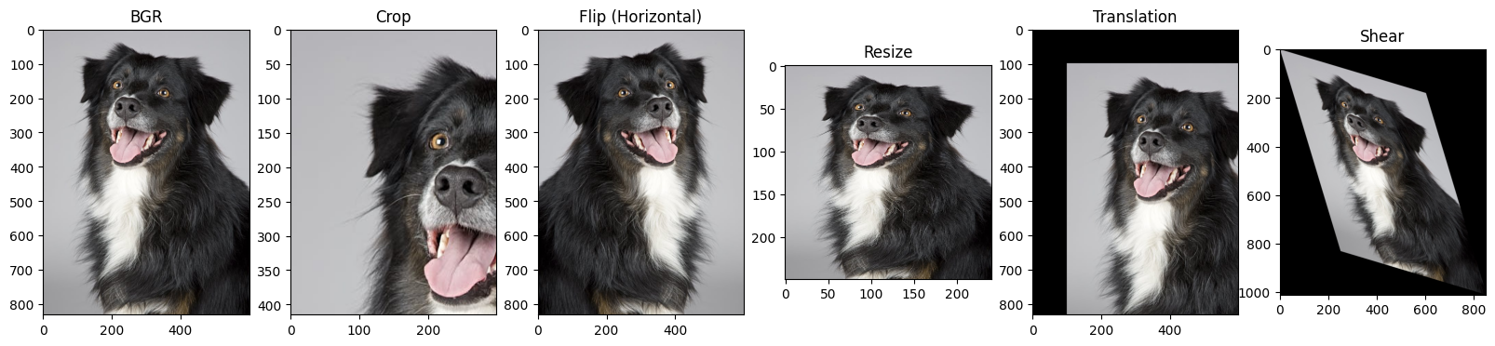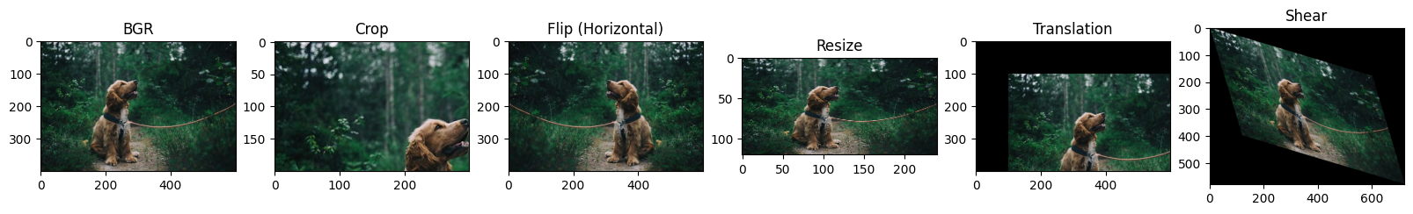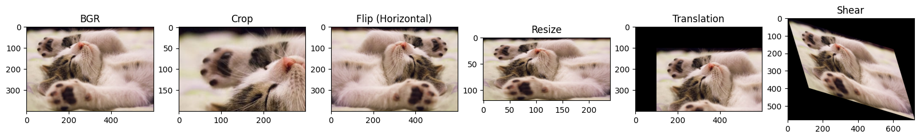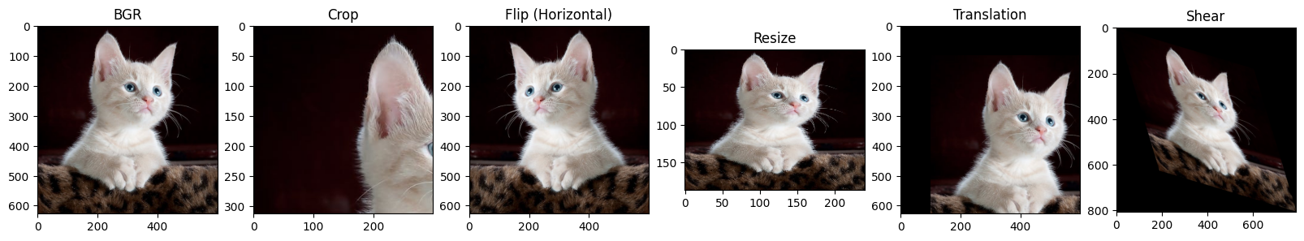

import cv2

import numpy as np

from matplotlib import pyplot as plt

img1 = cv2.imread('/content/img11.jpg')

img2 = cv2.imread('/content/img12.jpg')

img3 = cv2.imread('/content/img13.jpg')

img4 = cv2.imread('/content/img14.jpg')

img5 = cv2.imread('/content/img15.jpg')

print(f'Image1 shape - {img1.shape}')

print(f'Image2 shape - {img2.shape}')

print(f'Image3 shape - {img3.shape}')

print(f'Image4 shape - {img4.shape}')

print(f'Image5 shape - {img5.shape}')

img2 = cv2.resize(img2, (600, 900))

img4 = cv2.resize(img4, (600, 900))

img5 = cv2.resize(img5, (600, 900))

print(f'Image1 shape - {img1.shape}')

print(f'Image2 shape - {img2.shape}')

print(f'Image3 shape - {img3.shape}')

print(f'Image4 shape - {img4.shape}')

print(f'Image5 shape - {img5.shape}')

img_p = (0.2*img1)+(0.2*img2)+(0.2*img3)+(0.2*img4)+(0.2*img5)

img_p = img_p.astype('uint8')

plt.imshow(cv2.cvtColor(img_p, cv2.COLOR_BGR2RGB))

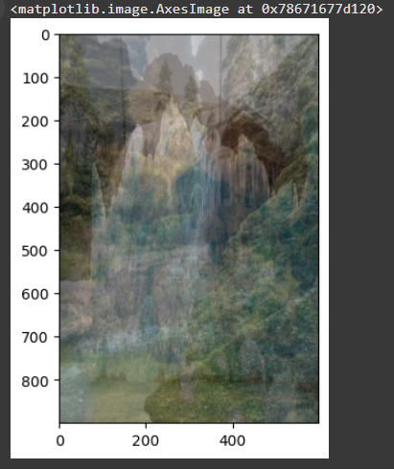

def gaussian_noise(img):

mean = 0

std_dev = 50

noise = np.random.normal(mean, std_dev, img_p.shape)

img_noise = img + noise

img_noise = np.clip(img_noise, 0, 255).astype('uint8')

_, (ax1,ax2,ax3) = plt.subplots(1,3,figsize=(25,10))

ax1.set_title('Normal image')

ax1.imshow(cv2.cvtColor(img, cv2.COLOR_BGR2RGB))

ax2.set_title('Noisy Image')

ax2.imshow(cv2.cvtColor(img_noise, cv2.COLOR_BGR2RGB))

ax3.set_title('Histogram')

ax3.hist(noise.ravel(), bins=100, density=True, color='r')

ax3.set_title('Histogram')

ax3.set_xlabel('Intensity')

ax3.set_ylabel('Frequency')

gaussian_noise(img_p)

